Downtown Moultrie Tomorrow, Inc.
Building for Sale
6 South Main Street
Moultrie, Ga

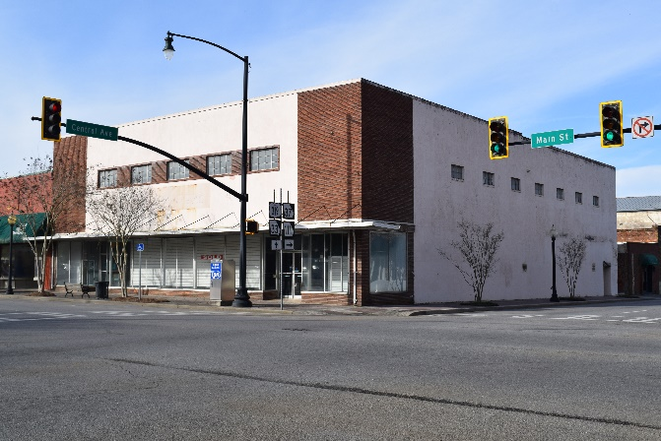
Overview
Building Square Footage: 17,797
Downtown Moultrie Tomorrow, Inc., a private organization, is accepting offers on this 2-story building, zoned C-3 Commercial, and located in the Downtown Moultrie Commercial Historic District.
DMT seeks a qualified developer to purchase and improve the existing building while enhancing Downtown.
Downtown Moultrie Tomorrow, Inc will consider all offers/proposals/plans for the building, including upscale retail, restaurant, residential, entertainment, or a combination that will enhance Downtown Moultrie. To be considered, offers must be submitted with a concept development proposal. Downtown Moultrie Tomorrow, Inc. reserves the right to reject any and all offers for any reason.

Offer/Proposal Format
Proposals should include the following:
1. Cover Sheet that must include: Name, Address, Contact Information
2. Offer
3. Proposal Narrative – A summary of the proposed development for the site.
4. Site Plan – Conceptual renditions of the site.
5. Financial Capacity – Provide a narrative explaining proposers’ qualifying development background experience demonstrating sufficient competency and financial resources to complete the land transaction and project development.
Financial Projections for proposed businesses should be included.
6. Project Schedule – Include a preliminary schedule for the development of the site.
7. Statement of Qualifications – Include descriptions of relevant example of Projects completed within the past five years that are comparable in scope to the project.
Sealed Offers/Proposals must be submitted by Monday, November 1, 4:00 p.m. to the Downtown Welcome Center, 31 East Central Avenue, Moultrie,
Attention Amy Johnson

Interested parties can coordinate property tours with Amy Johnson with at least two business days notice by calling 229-890-5455.

